Week:5
Experiment: 3
“To observe Catalase Enzyme Activity in Potato in the presence of Substrate Hydrogen peroxide (H₂O₂)”
Total Marks (30 Marks):
1) Lab Performance (10 Marks):
2) Observation (10 Marks):
S. No | Enzyme Concentration | Time taken by the disk  (Trial 1) | Time taken by the disk  (Trial 2) | Average
 | 20% | 130 | 170 | 150
 | 40% | 80 | 68 | 74
 | 60% | 52 | 54 | 53
 | 80% | 27 | 23 | 25
 | 100% | 19 | 16 | 17.5

3) Draw a graph between enzyme concentration and the average time taken by the disk (5 Marks):
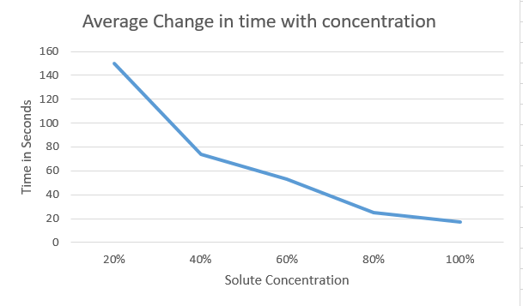

4) Result (4 Marks):
As we dip the disk containing potato enzymes in hydrogen peroxide, the following reaction takes place:-
$$2H_{2}O_{2}→2H_{2}O+ O_{2}↑$$
It releases oxygen, we measure the time taken for the disk to float up as an indicator of enzymes activity.
As the enzymes concentration increases, the average time decreases, at 20% concentration, the disk took 150 seconds (slow reaction). At 100%, it only took 17.5 seconds (fast reaction).
Higher enzymes= more catalase molecules available.
More catalase = faster breakdown of hydrogen peroxide.
Faster breakdown = quicker release of oxygen bubbles.
More oxygen bubbles = disk floats sooner.

5) Questions (1 Mark):
- What is the function of a control?
  - The control is a standard setup in an experiment where variable being tested is not applied. It allows us to compare our experimental results against baseline to see if the observed effect is truly due to variable being tested and not because of external reasons.

6) Problems:
- Variation in disk size and thickness, disks might have absorbed different amount of enzyme concentrations.
- Enzymes might have started reaction before us dipping it into hydrogen peroxide.
- Reaction time was not EXACT.
- Uneven mixing of potato solution.
Even after all of these problems we still managed to get a promising result, that means problems occurred were insufficient to affect our results.

